**ITS290F Human Computer Interaction & User Experience Design**

**Lab 1. Introduction to CodePen**

What you’ll learn in this lab:

* Understanding CodePen
* Creating a front-end page
* Using OLE to submit your lab work

CodePen is a cloud-based integrated development environment (IDE) for writing and sharing front-end code. It would be useful for us to try out our code in certain lab practices.

**1. Sign up CodePen**

Sign up a CodePen free account

1. Visit <http://codepen.io> .
2. Sign up with Email or your preferred methods, as shown in Figure 1.
3. Check your mailbox to activate your account, if applicable.
4. Login CodePen with your login credentials.

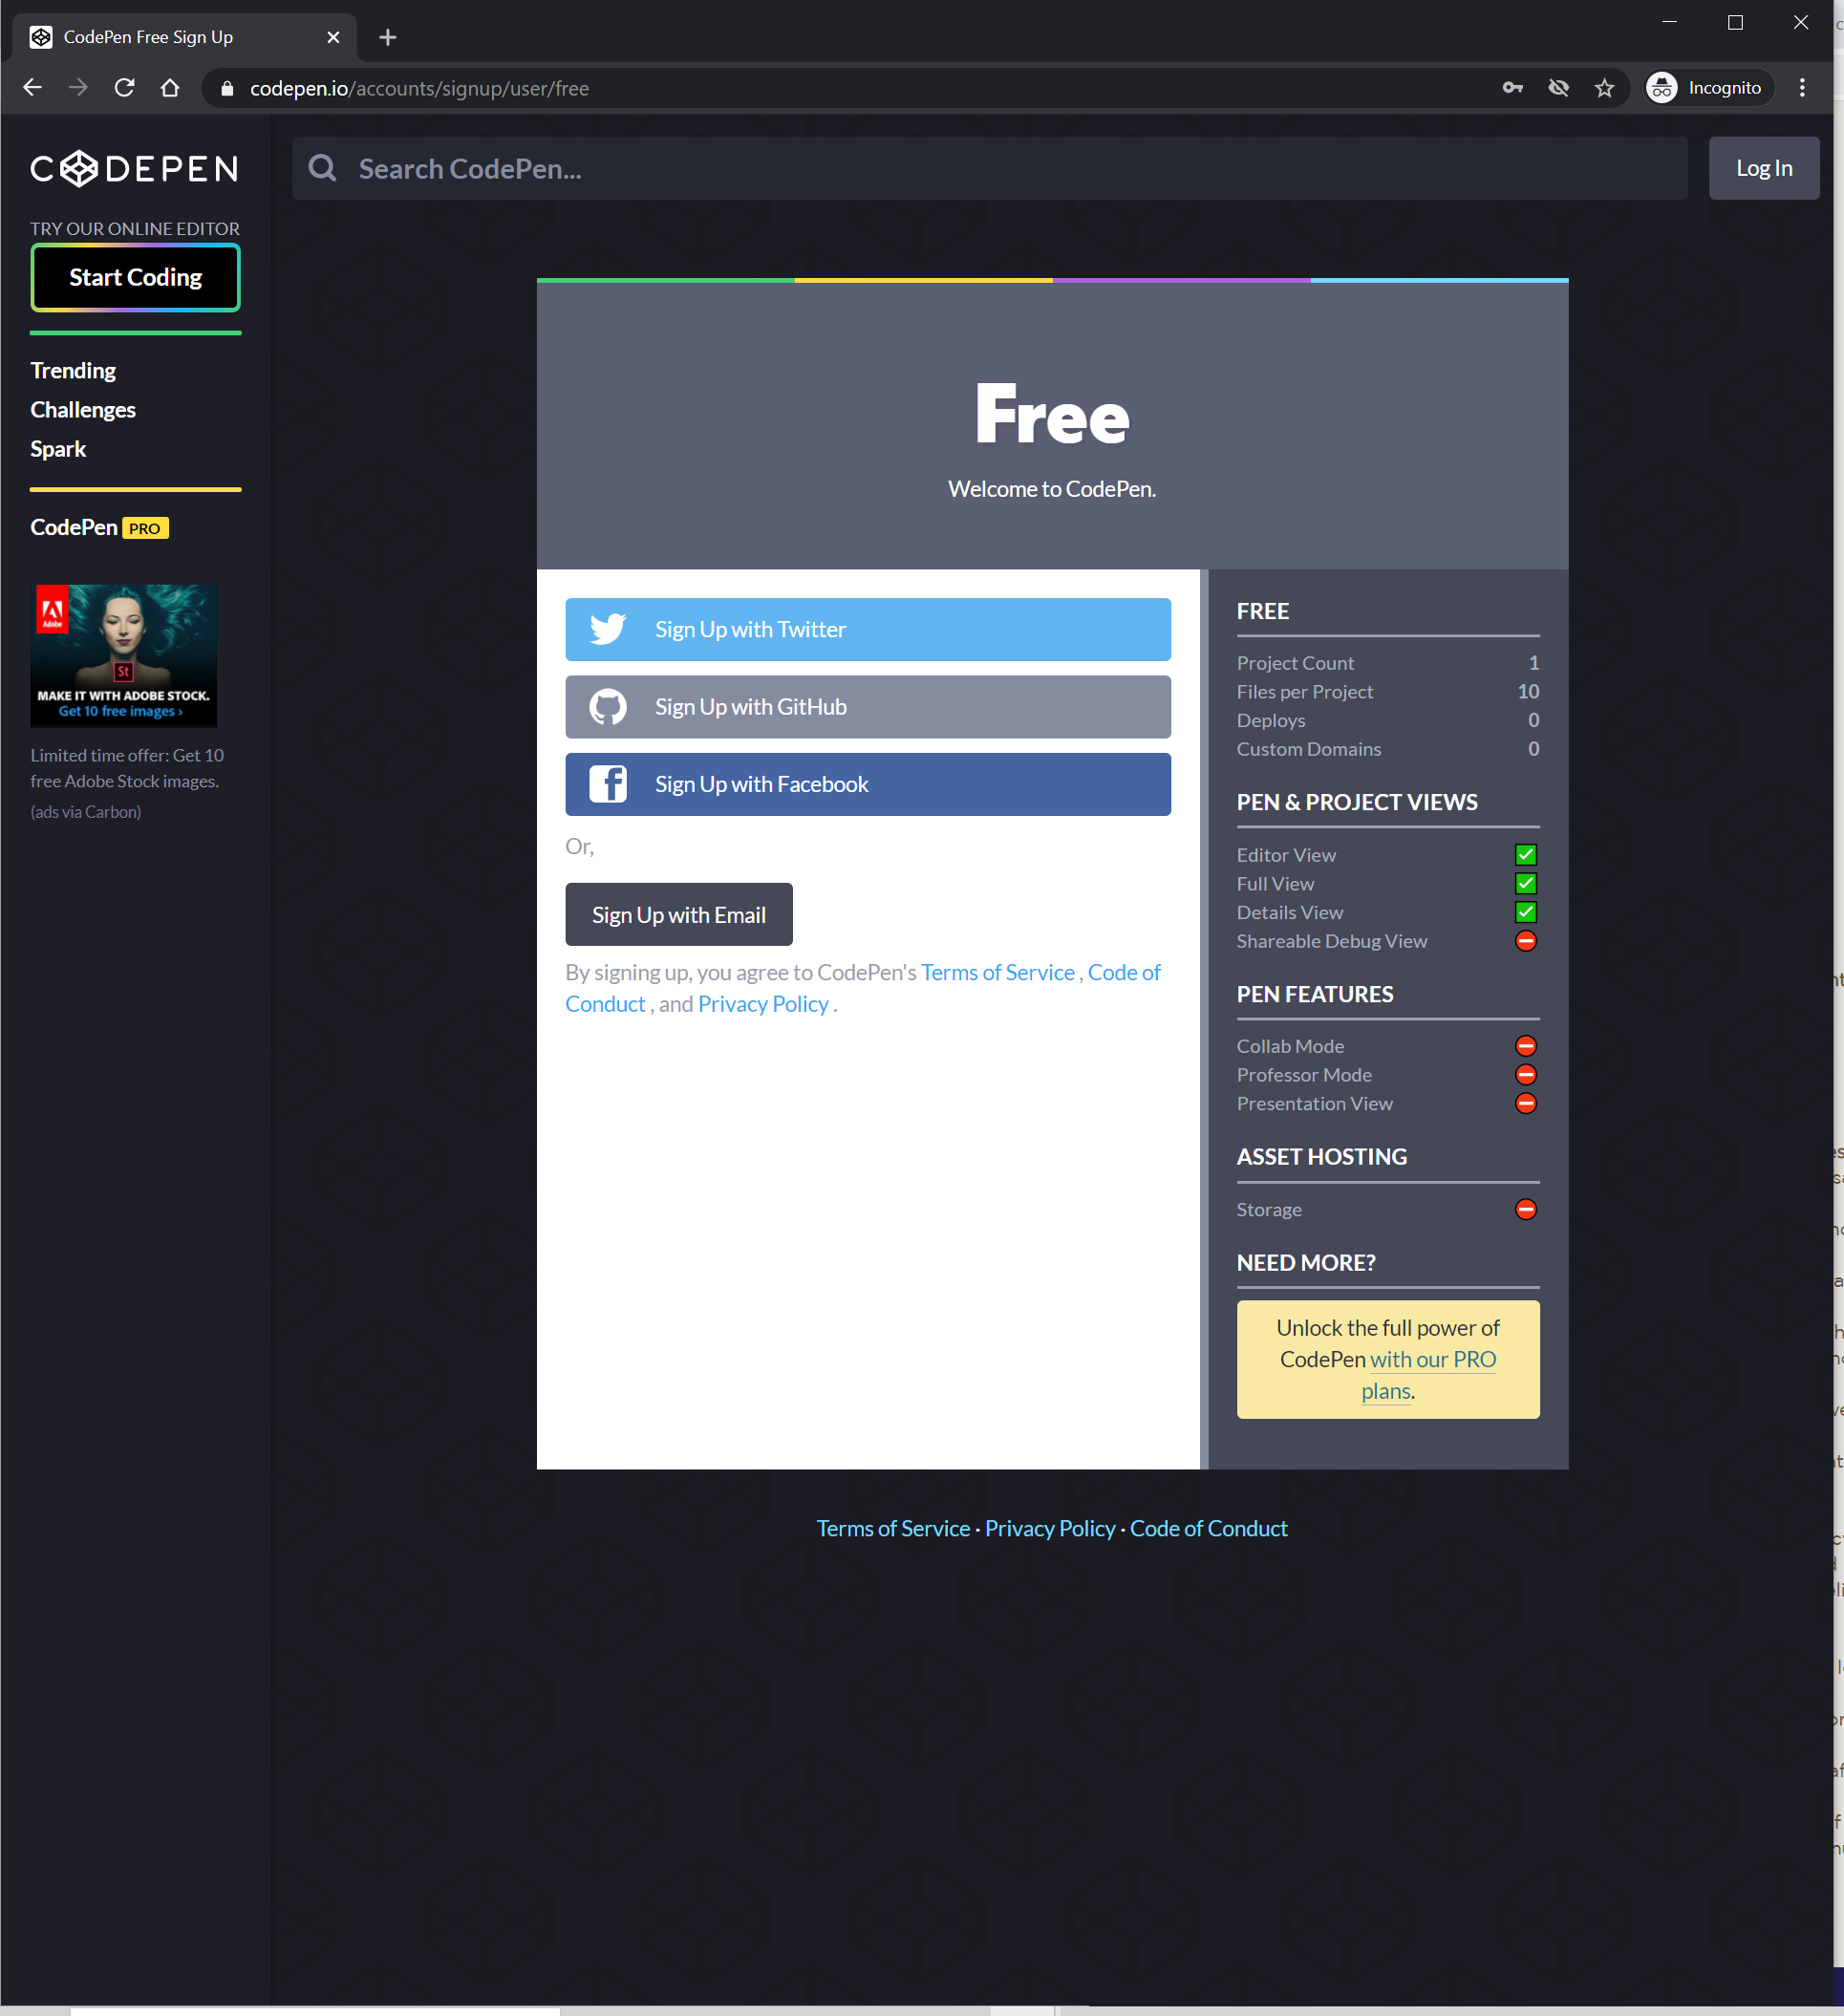

**FIGURE 1**

CodePen sign up page.

**2. Understanding the CodePen Editor**

Figure 2 shows the user interface of the CodePen Editor. It consists of 3 editor panels for HTML, CSS and JS that you can edit your code and scripts, and a live preview panel that shows the resulting webpage of your code.

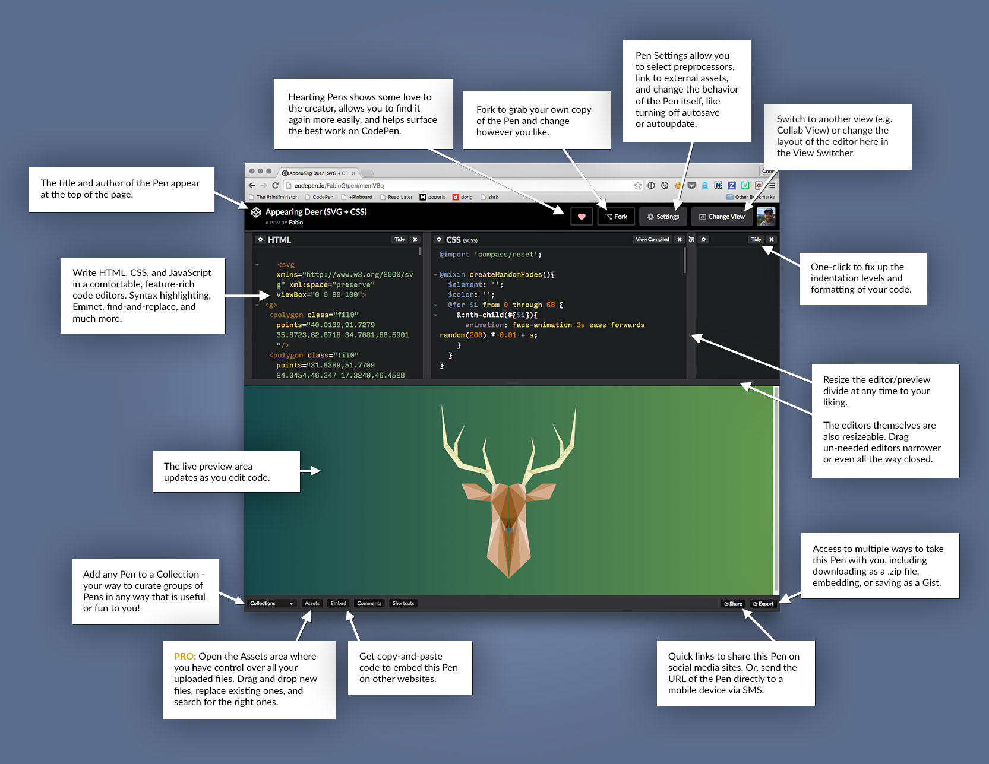

**FIGURE 2**

CodePen Editor.

**TRY IT YOURSELF**

|  |
| --- |
| **Taking an Editor Tour**  CodePen provides an online tutorial for you to get familiar with the user interface of the CodePen editor:   1. Go to <https://codepen.io/pen/tour/welcome> . 2. Follow the instructions and try it out. |

**3. Lab Exercises**

On your own, spend time becoming familiar with the CodePen interface. For this part, practice creating a Pen and attempting to finish the exercises.

**Exercise 1**

Create buttons that change the color of an HTML paragraph.

1. Create a new Pen.
2. Put the following code into the HTML window

<p id='hello'>Hello, World!</p>

<button onclick=changeColor('red')>Red</button>

1. Put the following code into the JS window

function changeColor(color) {

document.getElementById('hello').style.color=color;

}

1. Save and try clicking the “Red” button.
2. Add two buttons for changing color of “Hello, World” to **green** and **blue**.
3. Save and try clicking the new buttons.

**Exercise 2**

Learn reading JS reference from w3schools and create buttons that change the font style and weight of an HTML paragraph.

1. Continue to work on the code of Exercise 1. Add two buttons for changing the font style of “Hello, World” with Normal and *Italic* styles.
2. Create a new JS function with a parameter called changeFontStyle(style) .
3. Study the fontStyle property of JS on w3schools JS reference (<https://www.w3schools.com/jsref/prop_style_fontstyle.asp>) and complete the function.
4. Save and try clicking the new buttons.
5. Add three buttons for changing the font size of “Hello, World” with size “x-large”, “250%”, and “100px”. The outcome of the page should look like the follows:

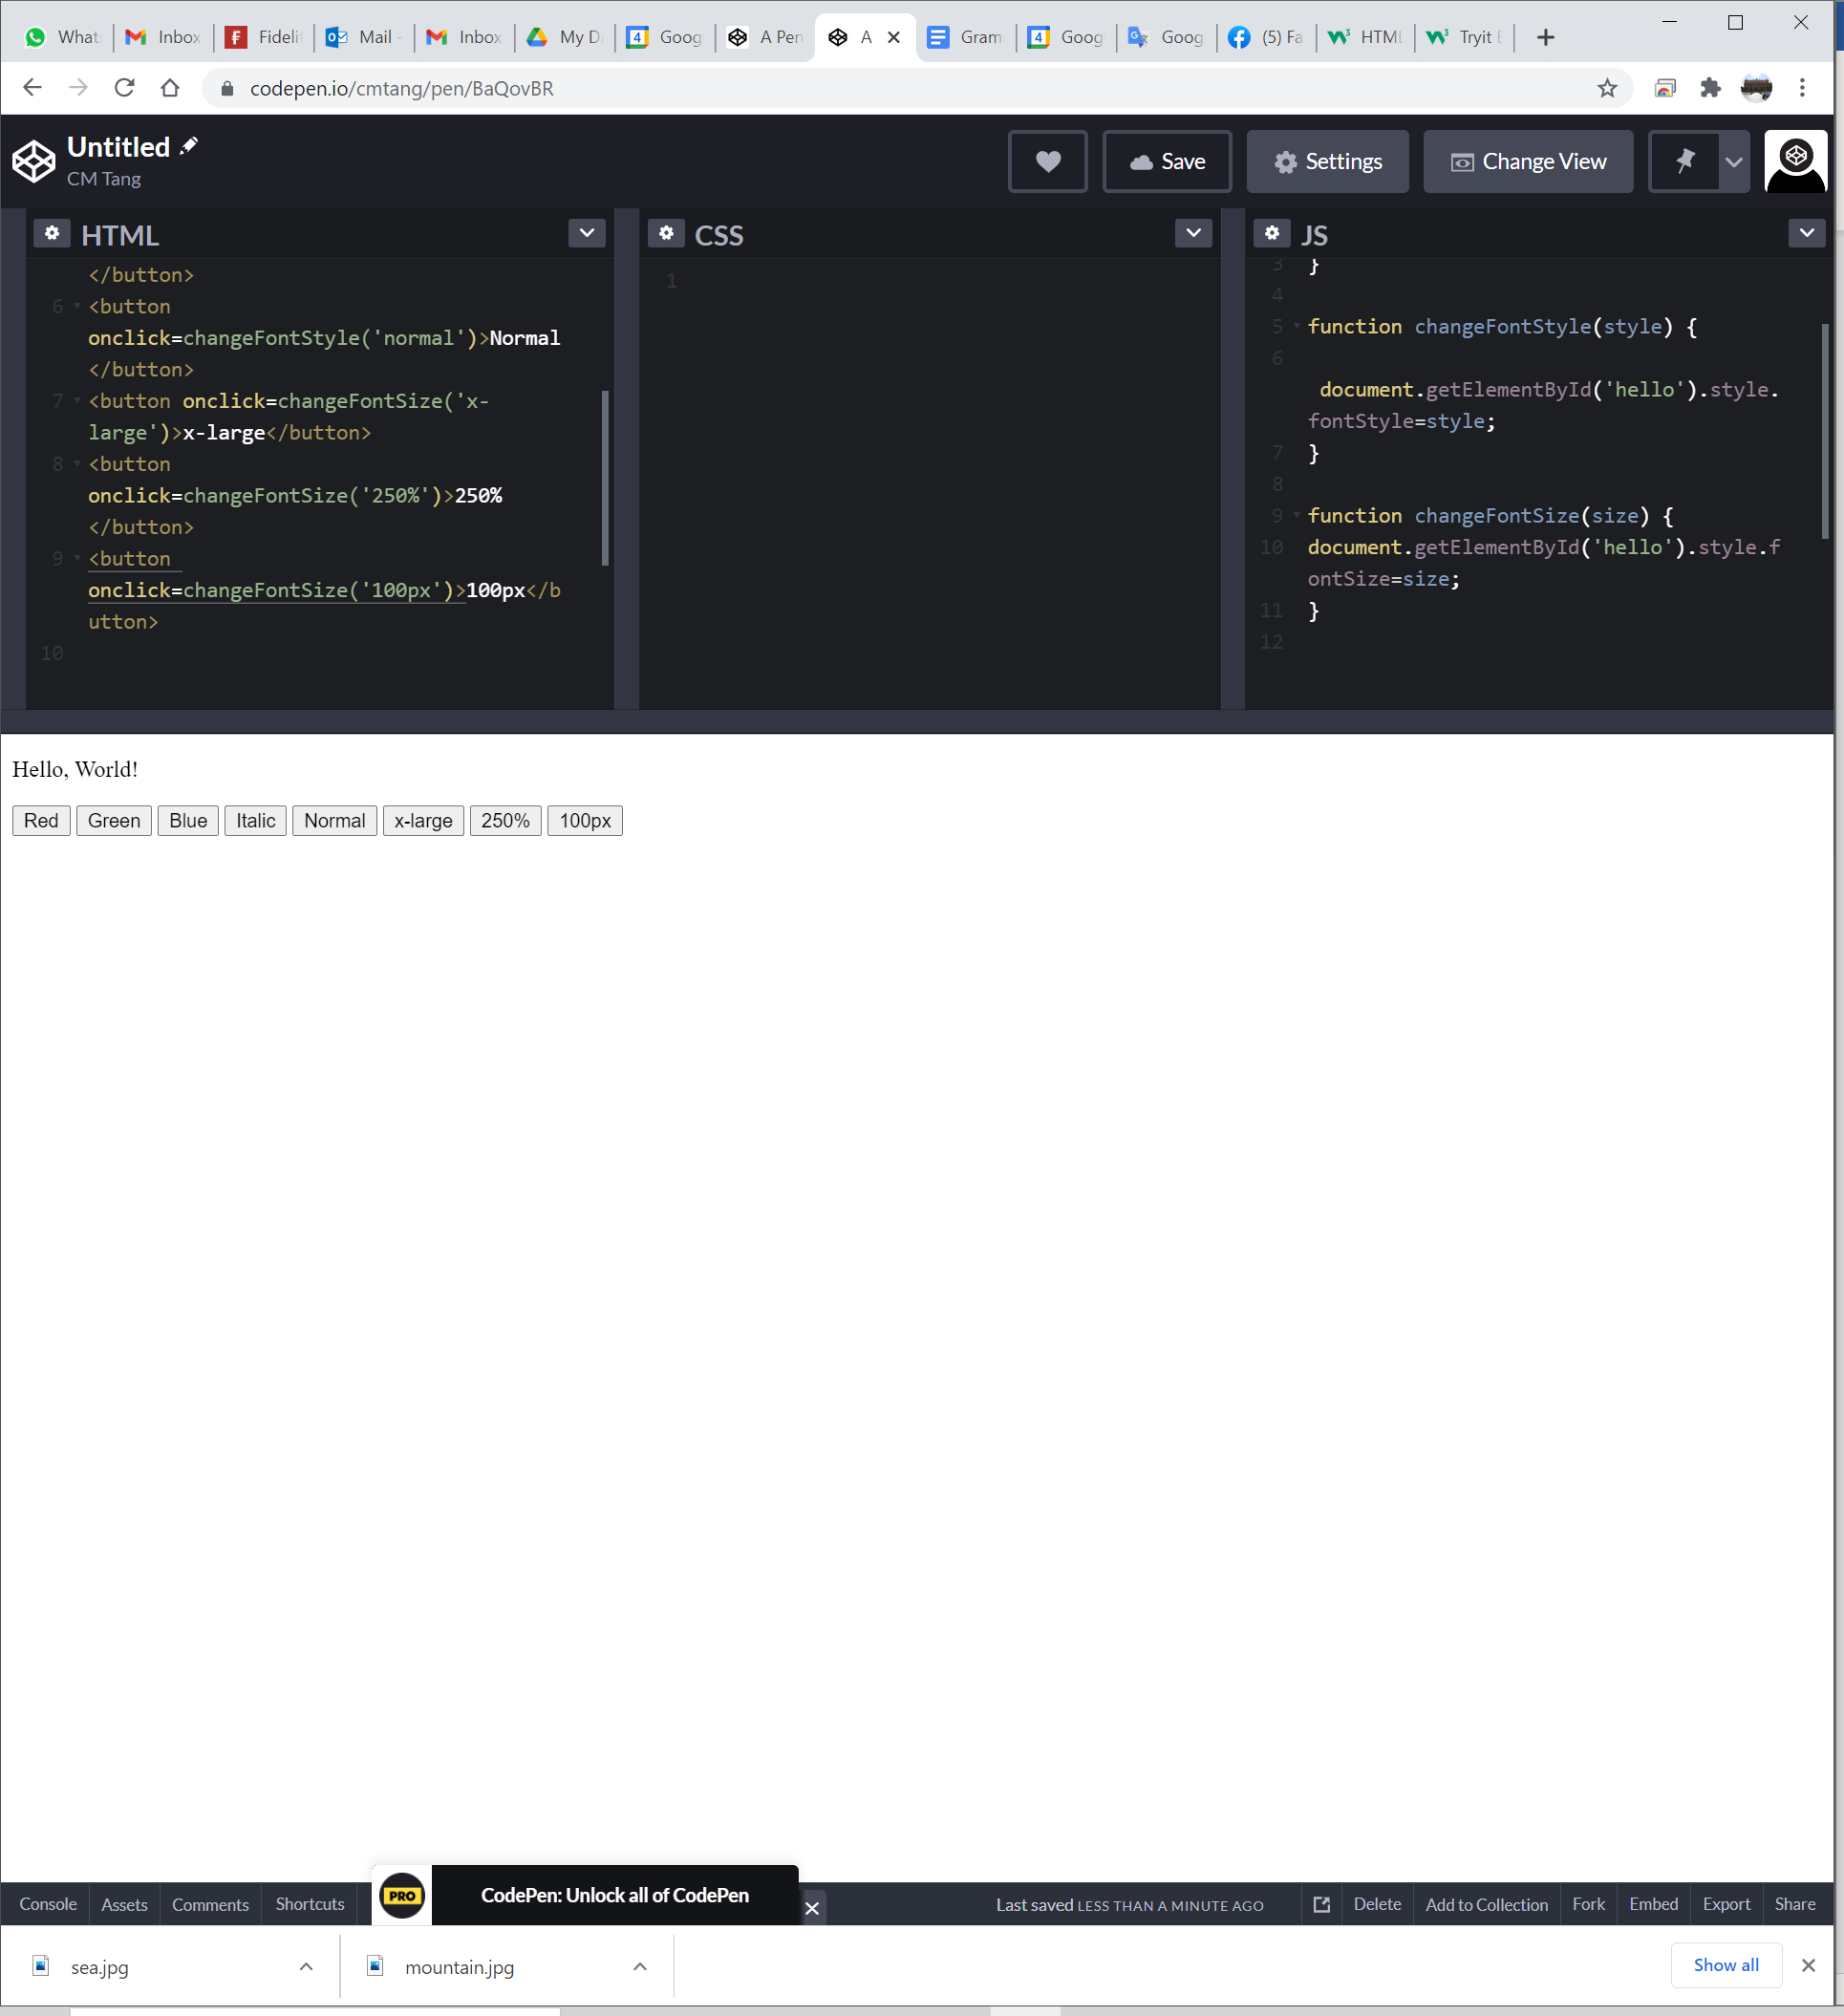

1. Create a new JS function with a parameter called changeFontSize(size) .
2. Study the fontSize property of JS on w3schools JS reference (<https://www.w3schools.com/jsref/prop_style_fontsize.asp>) and complete the function.
3. Save and try clicking the new buttons.

**Submission**

You will get 0 to 3% of OCAS score upon completing the lab exercises. Following the instruction below to submit your work.

1. Put your solution HTML and JS code inside the following answer boxes and save the file.
2. Upload this file via the corresponding submission link on OLE.

|  |
| --- |
| **Solution HTML code of Exercise 2** |
| Put your code here.  <p id="HW">Hello, World!</p>  <button onclick=ChangeColor('Red')>Red</button>  <button onclick=ChangeColor('Green')>Green</button>  <button onclick=ChangeColor('Blue')>Blue</button>  <button onclick=ChangeFontStyle('italic')>Italic</button>  <button onclick=ChangeFontStyle('normal')>Normal</button>  <button onclick=ChangeFontSize("x-large")>x-large</button>  <button onclick=ChangeFontSize("250%")>250%</button>  <button onclick=ChangeFontSize("100px")>100px</button> |

|  |
| --- |
| **Solution JS code of Exercise 2** |
| Put your code here.  function ChangeColor(color) {  document.getElementById('HW').style.color=color;  }  function ChangeFontStyle(style) {  document.getElementById("HW").style.fontStyle = style  }  function ChangeFontSize(size) {  document.getElementById("HW").style.fontSize = size;  } |

**Note:**

1. The submission deadline is 23:59 of the forthcoming Thursday. The submission link will be closed after the deadline.
2. Your submission not necessary to be all correct but should show your efforts. We grade your work according to its quality.
3. Make sure you submitted a correct file. You can resubmit your work before the deadline.

1. DO NOT modify the layout and format of this document, and DO NOT save it as other file formats, i.e., PDF. Your work will be extracted using an automated document parsing tools for grading.

--- End ---